Our Ref: _______________ Your Ref: ________________________ Date: __________________

Baptist Church

Baale Yaku Site Area, P. O. Box 644,

Ogbomoso, Oyo State. Tel. 07052425407

Email: [newsprinbaptistchurch@gmail.com](mailto:newsprinbaptistchurch@gmail.com)

Website: newspringbc.comze.com

NEW SPRING

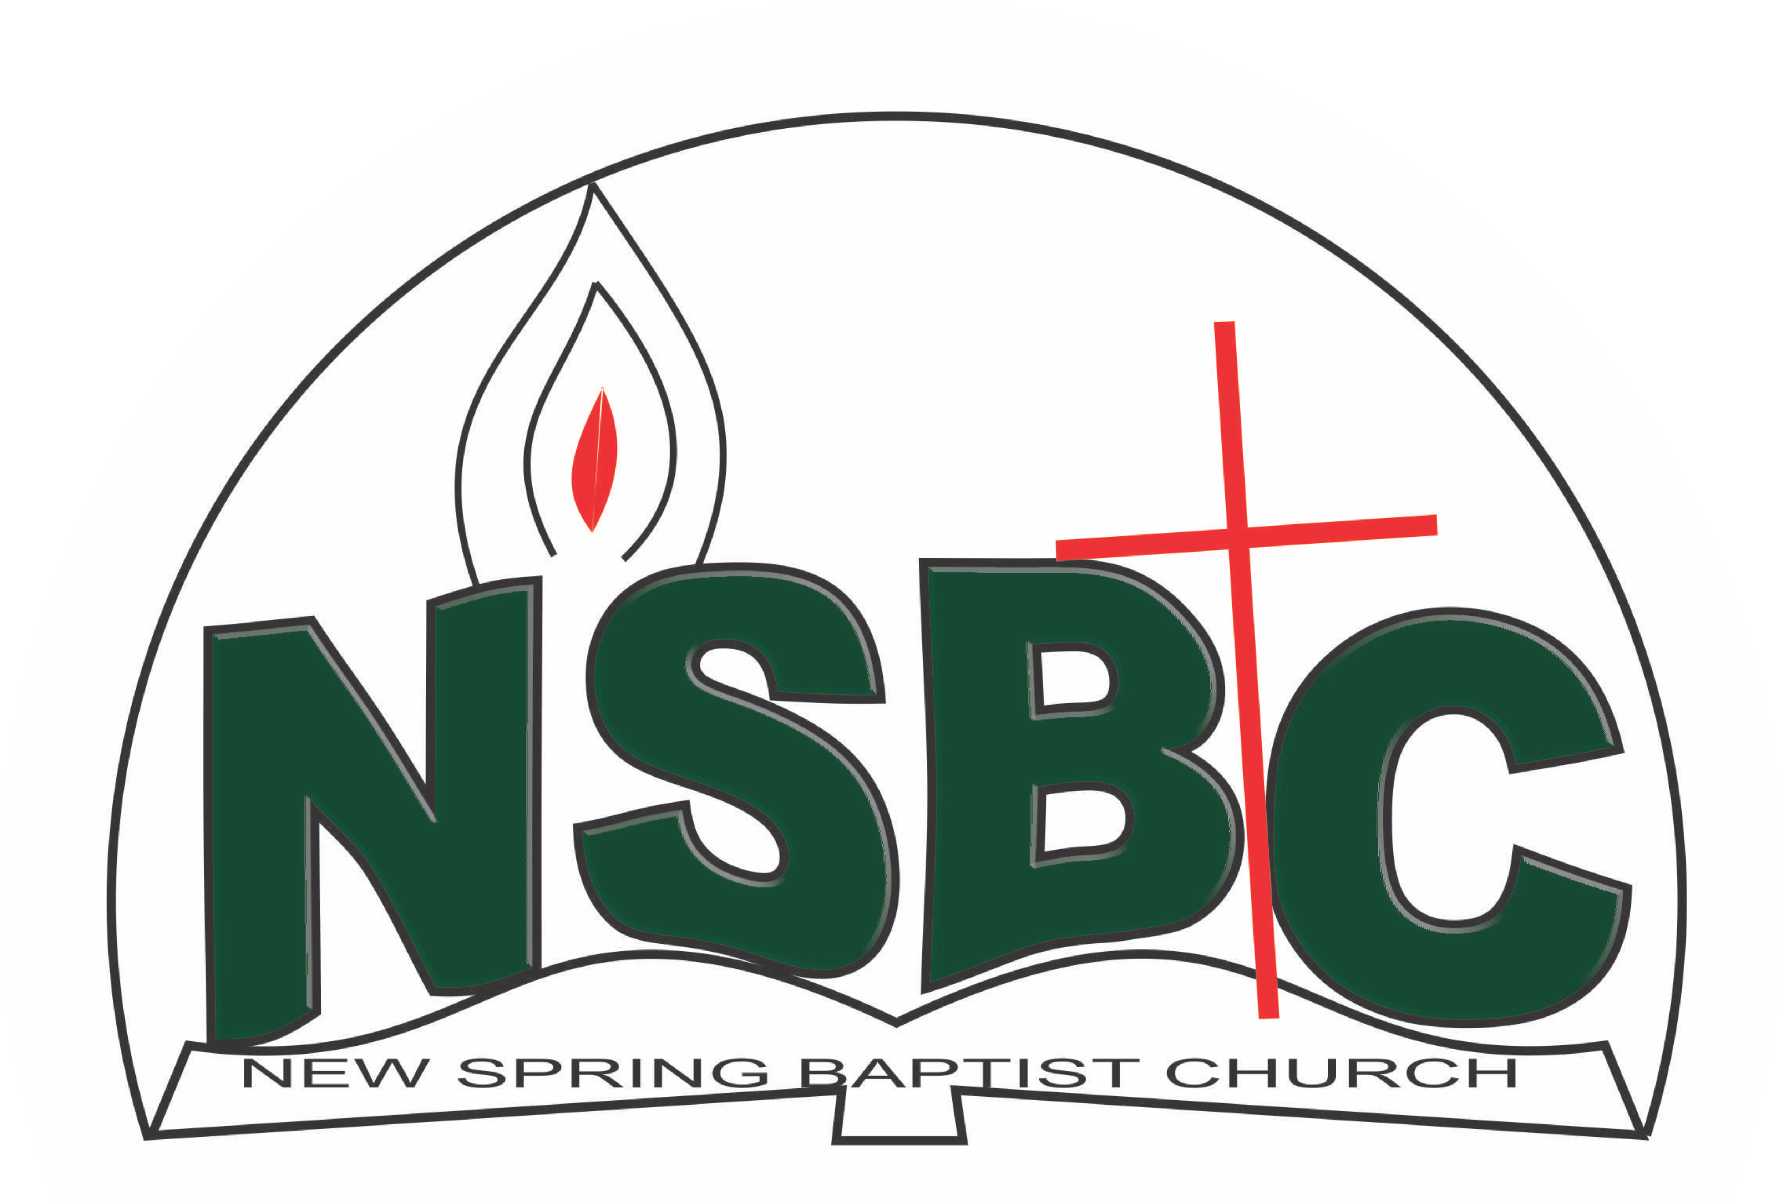

9 January 2022

Dear Mrs Sade Oyediran-Ajao,

Nomination to Serve as an Officer and Worker in the Church in 2022.

Calvary greetings in the precious name of our Lord and Saviour Jesus Christ. It is our pleasure to inform you that at the Church-in-Conference held on December 19, 2021; the Church ratified your nomination to serve in the following areas between January 1 and December 31, 2022:

1. Sunday School Teacher
2. Member, Church History Committee under the chairmanship of Mr. Yemi Alamu
3. Member, Hospitality Committee under the chairmanship of Mrs. Mobolape Adelakun
4. Member, Intercessors’ Committee under the chairmanship of Mrs. Funke Oyekunle
5. Member, Marriage Counseling Committee under the chairmanship of Rev. Kayode Oke
6. Member, Personnel Committee under the Chairmanship of Mrs. Mobolape Adelakun
7. Member, Stewardship Committee under the chairmanship of Mrs. Nia Olupona
8. Programme Chairperson, Women’s Missionary Union (WMU)
9. Church Treasurer and
10. Member, Church Council

Please refer to the table below for the key functions of each of these roles. Details can be found in the Church constitution. You are strongly encouraged to become familiar with the tasks as stated in the document. There will be an orientation of the Church workers on January 22, 2022 at 8:30 a.m. on the church premises. Please ensure you participate in this training.

“Now it is required that those who have been given a trust must prove faithful. I Corinthians 4:2”. May God find you faithful in the task He has assigned to you.

| Domain | Key function of Office, Department or Committee |
| --- | --- |
| Sunday School Teacher | To provide support to the Church Pastor in the teaching ministry of the Church to ensure that members and regular worshippers are well grounded in the Scriptures. |
| Church History Committee | The purpose of the committee is to document past and current key events in a systematic manner so that the evolution of the Church can be understood when her history is reviewed in the future. |
| Hospitality Committee | Responsible for organizing social activities of the Church |
| Intercessor Committee | The committee is responsible for standing in the gap on behalf of the Church and her members |
| Marriage Counselling Committee | The committee is responsible for acquainting prospective couples of behavioural patterns expected of those who wish to get married in the Church or those who request the Church to participate in their wedding ceremony |
| Personnel Committee | The committee is to assist the Church in matters relating to personnel administration. |
| Stewardship Committee | The committee is responsible for the overall management of the Church’s fiscal policy. |
| Church Treasurer | To provide support to the Church Pastor in ensuring safe keeping of all monies received by the Church for effective ministry and To keep accurate record of all monies received and disburse as per agreed budget |
| Church Council | The Church Council is the governing body of the Church whose membership, under the leadership of the Holy Spirit, holds one another mutually accountable with respect and love and sees to the smooth running of the Church. |
| Programe Chairperson, WMU | To coordinate and organize the WMU programe and carry out duties assigned by the President |

Thank you for accepting to serve in this Church.

Yours in His service

Olusayo Okediji Blessed Agboola

Church Secretary                                                                                     Chairman, Nominating Committee